NOTES: Class Plan for Understanding Shakespeare
And The Tragedy of Othello, The Moor of Venice
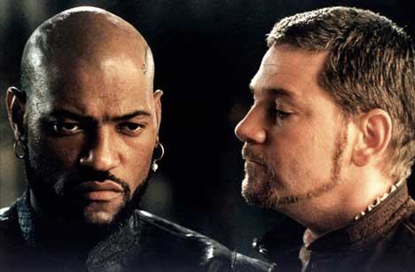
→HANDOUT: On Shakespeare’s significance, from Stephen Greenblatt’s Will in the World: How Shakespeare Became Shakespeare (NY: WW Norton & Co., 2004).

→GROUP WORK
Assemble in three groups to summarize the main action, significant dialogue, and important ideas from Acts 1 through 3. Suggestions: Break each Act down to component Scenes, and work as a team.
Laurence Fishburne and Kenneth Branagh in Othello (1995)

→CONCEPTS, MOTIFS, AND THEMES FOR CLASS DISCUSSION AFTER GROUP REPORTS
Seeming (appearance versus reality, light versus dark)
Seeing (eyes/sight versus blindness, visual appearance versus material proof)
Being (inner substance versus outer show, self versus others, self versus the Other)
Dehumanizing (humanity versus animality, civilization vs. nature, citizen vs. outsider)
Motivation (ambition, loyalty, love, lust, revenge, wrath, passion, rationality, jealousy)
Difference (gender, age, race, culture, religion, status, power)

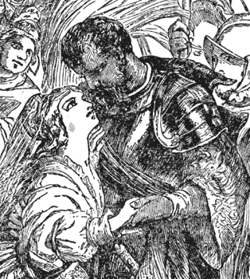
→IMPORTANT ELEMENTS OF SHAKESPEARE
SOURCE: Charles & Mary Lamb, Tales from Shakespeare (1901)
Poetic meter: See text-description page 793 and example in Othello on page 860 line 100…
Historicism: Of author, plot, enveloping action, source-story, production of the play, and England, with Venice standing in for London — example, handout from Dogs of God: Columbus, the Inquisition, and the Defeat of the Moors (James Reston, NY: Anchor Books, 2005) plus Othello’s tale on page 865 lines 130 through 170…
Imperial entertainment: Shakespeare wrote plays to entertain the groundlings and the nobility who could afford nice seats, and his theater was patronized by both Queen and commoner — this entertainment took inspiration from both high sources (classical poetry, history, drama, and philosophy) and low sources (popular lore, romances, mysteries, songs, and tales) at the height of the Elizabethan age, when England became a global empire through New World colonization, global competition, and assimilation of native peoples and cultures from around the world…
Catharsis: The public drunkenness and brawling in Act 2 Scene 3 suggest anarchy and misrule that will lead to murder and civic instability — Shakespeare’s plays often flirted with dangerous and off-color scenarios that commented on the state and power of England while catering to his audience’s taste for juicy theatrical action…

→QUESTIONS: What is Othello’s tragic flaw? What issues and actions contribute to the tragedy? What message(s) do you think Shakespeare had in mind for his audiences?

